**ONLINE ADVERTISING PERFORMANCE DATASET**

* **Sharon Blessy J V**

1. **What is the overall trend in user engagement throughout the campaign period?**

**Ans.**

***Code Snippet:***

*print(ad['user_engagement'].value_counts())*

*sns.countplot(x='user_engagement', hue='month', data=ad)*

*plt.xlabel('User Engagement')*

*plt.title('Overall Trend of User Engagement By Month')*

*plt.show()*

**Output:**

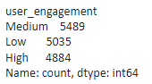

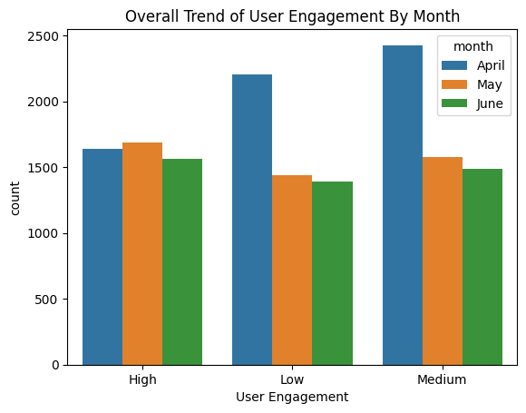

1. **How does the size of the ad (banner) impact the number of clicks generated?**

**Ans.**

***Code Snippet:***

*click_size_count = ad.groupby('banner')['clicks'].count()*

*print(click_size_count)*

*sns.countplot(x='banner', data=ad)*

*plt.xlabel('Banner Size')*

*plt.title('Impact of the no. of clicks by the size of ad')*

*plt.xticks(rotation=45)*

*plt.show()*

**Output:**

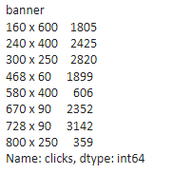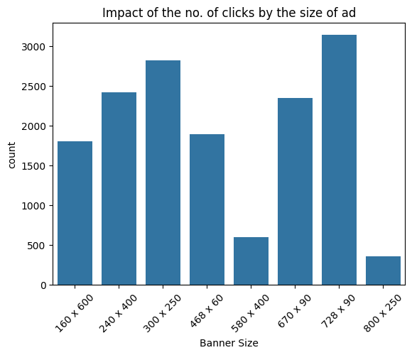

1. **Which publisher spaces (placements) yielded the highest number of displays and clicks?**

**Ans.**

***Code Snippet:***

*placement_stats = ad.groupby('placement')[['clicks', 'displays']].sum()*

*print(placement_stats)*

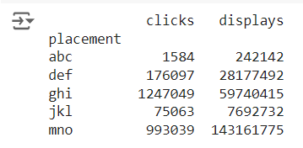MNO has the highest displays while GHI has the highest clicks.

1. **Is there a correlation between the cost of serving ads and the revenue generated from clicks?**

**Ans.**

***Code Snippet:***

*corr_coeff = ad['cost'].corr(ad['revenue'])*

*print(f'Correlation coefficient of cost and revenue: {corr_coeff}')*

*plt.scatter(ad['cost'], ad['revenue'])*

*plt.xlabel('Cost')*

*plt.ylabel('Revenue')*

*plt.title('Scatter plot indicating correlation between Cost and Revenue')*

*plt.show()*

**Output:**



This indicates a strong positive relationship.

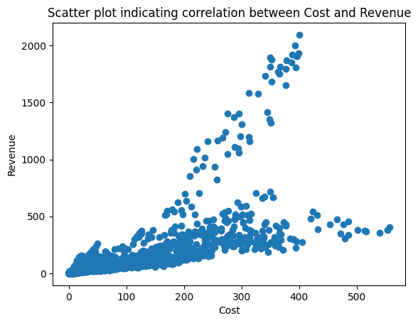

1. **What is the average revenue generated per click for Company X during the campaign period?**

**Ans.**

***Code Snippet:***

*tot_revenue = ad['revenue'].sum()*

*tot_clicks = ad['clicks'].sum()*

*avg_revenue_per_click = tot_revenue / tot_clicks*

*print("Average revenue generated per click:", avg_revenue_per_click)*

**Output:**

1. **Which campaigns had the highest post-click conversion rates?**

**Ans.**

***Code Snippet:***

*filter_ad = ad[ad['clicks'] != 0]*

*filter_ad['post_click_conversion_rate'] = filter_ad['post_click_conversions'] / filter_ad['clicks']*

*campaign_conversion_rates = filter_ad.groupby('campaign_number')['post_click_conversion_rate'].mean()*

*print(campaign_conversion_rates)*

*highest_conversion_campaign = campaign_conversion_rates.idxmax()*

*print("Campaign with the highest post-click conversion rate:", highest_conversion_campaign)*

**Output:**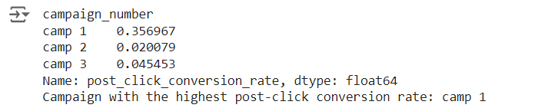

1. **Are there any specific trends or patterns in post-click sales amounts over time?**

**Ans.**

***Code Snippet:***

*monthly_sales = ad.groupby('month')['post_click_sales_amount'].mean()*

*print(monthly_sales)*

*plt.bar(monthly_sales.index, monthly_sales.values)*

*plt.xlabel('Month')*

*plt.ylabel('Average Post-Click Sales Amount')*

*plt.title('Specific Trends in Post-Click Sales Amount Over Months')*

*plt.show()*

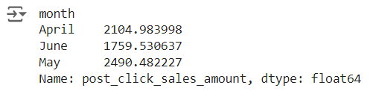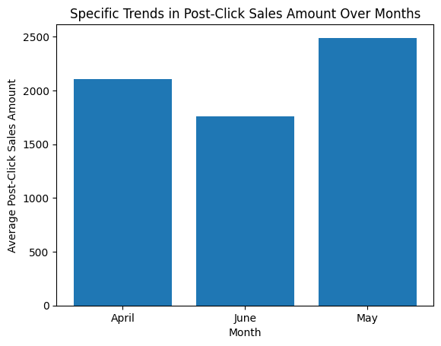

1. **How does the level of user engagement vary across different banner sizes?**

**Ans.**

***Code Snippet:***

*engagement_mapping = {'Low': 1, 'Medium': 2, 'High': 3}*

*ad['user_engagement_val'] = ad['user_engagement'].map(engagement_mapping)*

*engagement_banner = ad.groupby('banner')['user_engagement_val'].mean()*

*print(engagement_banner)*

*plt.bar(engagement_banner.index, engagement_banner.values)*

*plt.xlabel('Banner Size')*

*plt.ylabel('Average User Engagement')*

*plt.title('Variation of User Engagement Across Banner Sizes')*

*plt.xticks(rotation=45)*

*plt.show()*

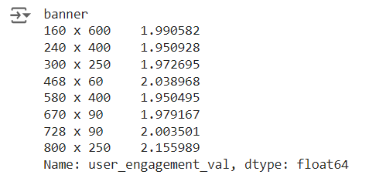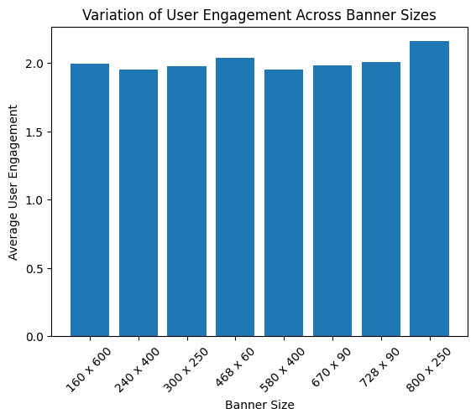

1. **Which placement types result in the highest post-click conversion rates?**

**Ans.**

***Code Snippet:***

*filter_ad = ad[ad['clicks'] != 0]*

*filter_ad['post_click_conversion_rate'] = filter_ad['post_click_conversions'] / filter_ad['clicks']*

*placement_conversion_rates = filter_ad.groupby('placement')['post_click_conversion_rate'].mean()*

*print(placement_conversion_rates)*

*highest_conversion_placement = placement_conversion_rates.idxmax()*

*print("Placement types with  highest post-click conversion rate:", highest_conversion_placement)*

**Output:**

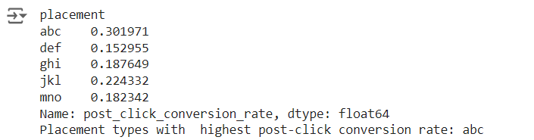

1. **Can we identify any seasonal patterns or fluctuations in displays and clicks throughout the campaign period?**

**Ans.**

***Code Snippet:***

*camp_data = ad.groupby('month')[['displays', 'clicks']].sum()*

*print(camp_data)*

*plt.plot(camp_data.index, camp_data['displays'], label='Displays')*

*plt.plot(camp_data.index, camp_data['clicks'], label='Clicks')*

*plt.xlabel('Month')*

*plt.ylabel('Count')*

*plt.title('Seasonal Patterns in Displays and Clicks')*

*plt.legend()*

*plt.show()*

**Output:**

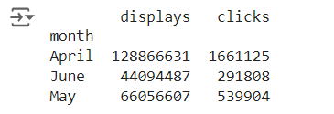

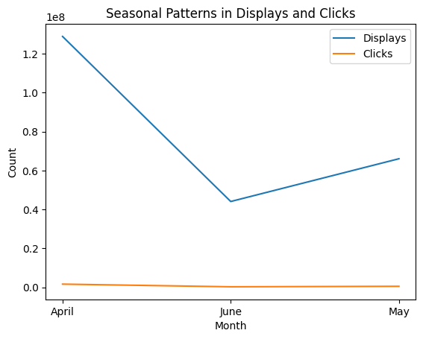

1. **Is there a correlation between user engagement levels and the revenue generated?**

**Ans.**

***Code Snippet:***

*corr_rev_user = ad.groupby('user_engagement')['revenue'].sum()*

*print(corr_rev_user)*

*plt.bar(corr_rev_user.index, corr_rev_user.values)*

*plt.xlabel('Level of User Engagement')*

*plt.ylabel('Total Revenue Generated')*

*plt.title('Correlation Between User Engagement and Revenue')*

*plt.show()*

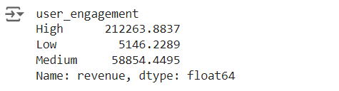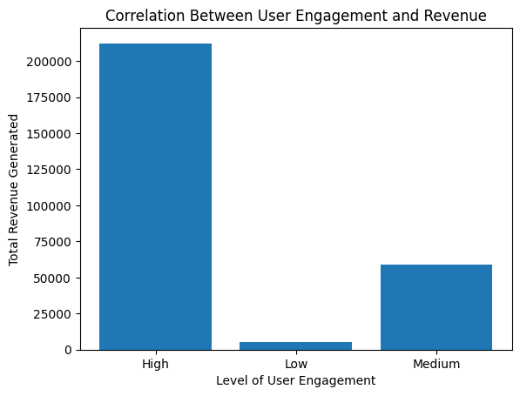

1. **Are there any outliers in terms of cost, clicks, or revenue that warrant further investigation?**

**Ans.**

***Code Snippet:***

*sns.boxplot(data=ad[['cost', 'clicks', 'revenue']])*

*plt.title('Boxplot of Cost, Clicks, and Revenue')*

*plt.show()*

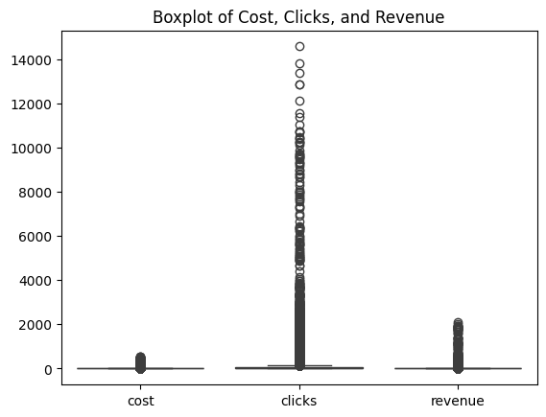

1. **How does the effectiveness of campaigns vary based on the size of the ad and placement type?**

**Ans.**

***Code Snippet:***

*filter_ad = ad[ad['clicks'] != 0]*

*post_click_conversion_rate = filter_ad['post_click_conversions'] / filter_ad['clicks']*

*user_engagement_mapping = {'High': 3, 'Medium': 2, 'Low': 1}*

*ad['user_engagement_numeric'] = ad['user_engagement'].map(user_engagement_mapping)*

*effectiveness = filter_ad.groupby(['banner', 'placement'])['user_engagement_numeric'].mean()*

*print(effectiveness)*

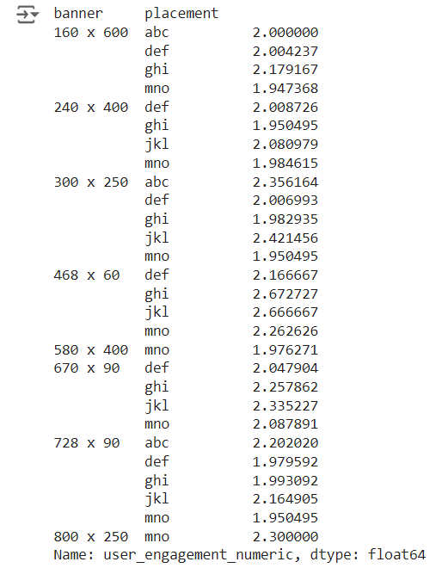

1. **Are there any specific campaigns or banner sizes that consistently outperform others in terms of ROI?  
   Ans.**

***Code Snippet:***

*filter_ad = ad[ad['cost'] != 0]*

*filter_ad['ROI'] = (filter_ad['revenue'] - filter_ad['cost']) / filter_ad['cost']*

*roi_by_campaign_banner = filter_ad.groupby(['campaign_number', 'banner'])['ROI'].mean().reset_index()*

*top_campaigns = roi_by_campaign_banner.sort_values('ROI', ascending=False).head(10)*

*print("Top Performing Campaigns and Banner Sizes by ROI:")*

*print(top_campaigns)*

*plt.figure(figsize=(12, 6))*

*sns.barplot(x='campaign_number', y='ROI', hue='banner', data=roi_by_campaign_banner)*

*plt.title('ROI by Campaign and Banner Size')*

*plt.xlabel('Campaign Number')*

*plt.ylabel('Return on Investment (ROI)')*

*plt.xticks(rotation=45)*

*plt.legend(title='Banner Size')*

*plt.tight_layout()*

*plt.show()*

**Output:**

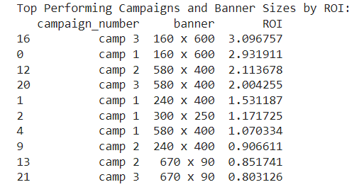

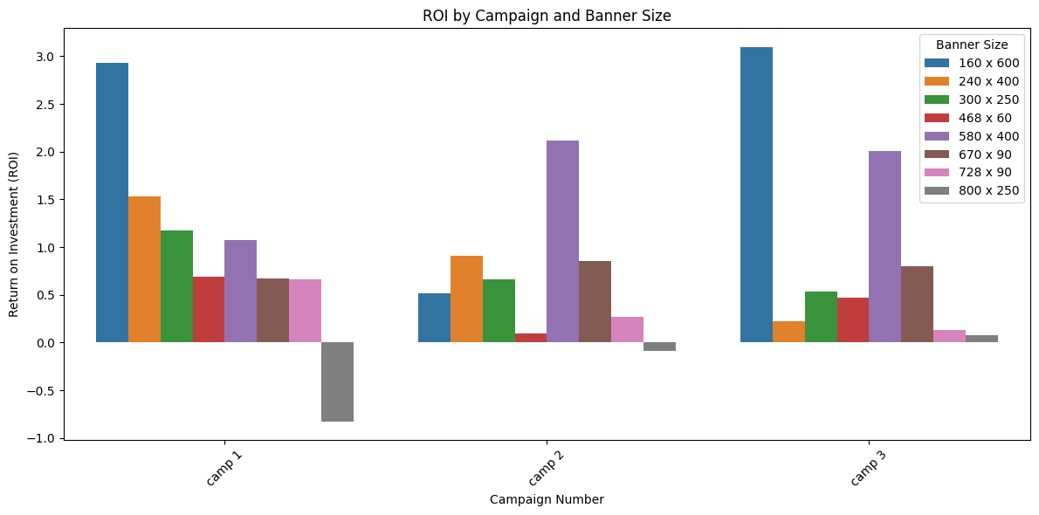

1. **What is the distribution of post-click conversions across different placement types?**

**Ans.**

***Code Snippet:***

*conv_placement = ad.groupby('placement')['post_click_conversions'].sum()*

*print(conv_placement)*

*plt.bar(conv_placement.index, conv_placement.values)*

*plt.xlabel('Placement Type')*

*plt.ylabel('Total Post-Click Conversions')*

*plt.title('Distribution of Post-Click Conversions Across Placement Types')*

*plt.show()*

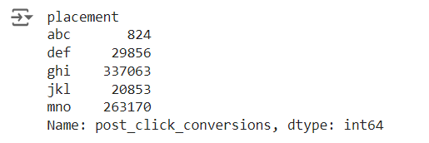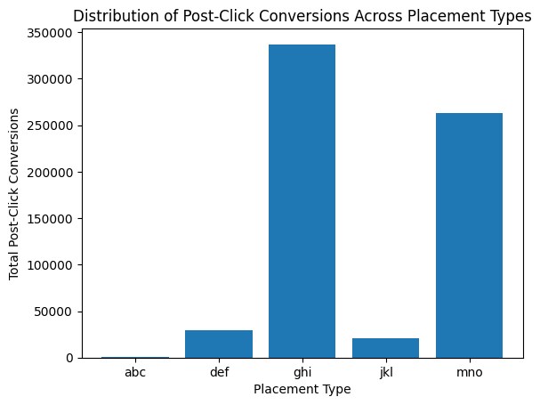

1. **Are there any noticeable differences in user engagement levels between weekdays and weekends?**

**Ans.**

***Code Snippet:***

*month_map = {'April':'04', 'May':'05', 'June' : '06'}*

*ad['month'] = ad['month'].apply(lambda x: month_map[x])*

*ad['date'] = ad['month'].astype(str) + '/' + ad['day'].astype(str) + '/2020'*

*ad['date'] = pd.to_datetime(ad['date'], format='%m/%d/%Y')*

*ad['weekday'] = ad['date'].dt.day_name()*

*engagement_weekday = ad.groupby('weekday')['user_engagement'].value_counts().unstack().fillna(0)*

*print("User Engagement by Weekday:")*

*print(engagement_weekday)*

**Output:**

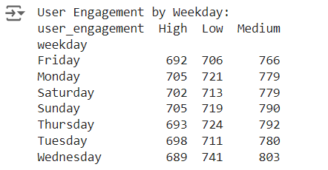

1. **How does the cost per click (CPC) vary across different campaigns and banner sizes?**

**Ans.**

***Code Snippet:***

*filter_ad = ad[ad['clicks'] != 0]*

*filter_ad['CPC'] = filter_ad['cost'] / filter_ad['clicks']*

*cpc_range = filter_ad.groupby(['campaign_number', 'banner'])['CPC'].mean()*

*print(cpc_range)*

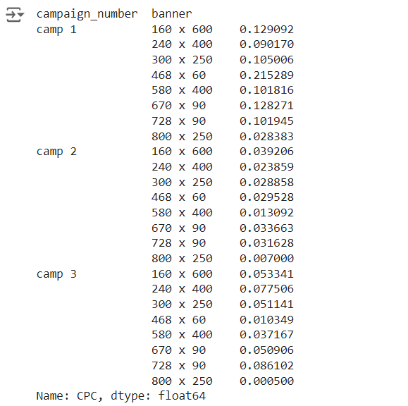

1. **Are there any campaigns or placements that are particularly cost-effective in terms of generating post-click conversions?**

**Ans.**

***Code Snippet:***

*filter_ad = ad[ad['post_click_conversions'] != 0]*

*filter_ad['cost_per_conversion'] = filter_ad['cost'] / filter_ad['post_click_conversions']*

*cost_effectiveness = filter_ad.groupby(['campaign_number', 'placement'])['cost_per_conversion'].mean().reset_index()*

*cost_effectiveness = cost_effectiveness.sort_values('cost_per_conversion')*

*print(cost_effectiveness.head(10))*

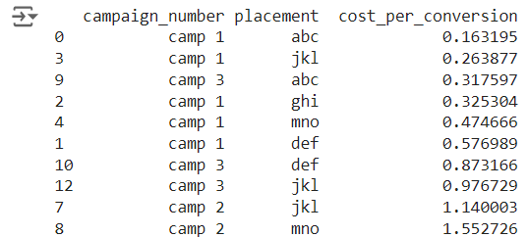

1. **Can we identify any trends or patterns in post-click conversion rates based on the day of the week?**

**Ans.**

***Code Snippet:***

*month_map = {'April':'04', 'May':'05', 'June' : '06'}*

*ad['date'] = ad['month'].astype(str) + '/' + ad['day'].astype(str) + '/2020'*

*ad['date'] = pd.to_datetime(ad['date'], format='%m/%d/%Y')*

*ad['weekday'] = ad['date'].dt.day_name()*

*conv_weekday = ad.groupby('weekday')['post_click_conversions'].mean().fillna(0)*

*print("Post-click-conversions by Weekday:")*

*print(conv_weekday)*

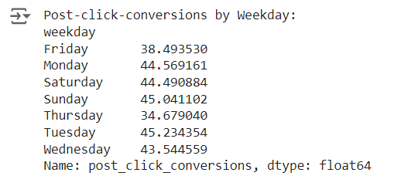

1. **How does the effectiveness of campaigns vary throughout different user engagement types in terms of post-click conversions?**

**Ans.**

***Code Snippet:***

*ad.fillna({'campaign_number': 0, 'user_engagement': 'Unknown', 'post_click_conversions': 0}, inplace=True)*

*campaign_effectiveness_by_engagement = ad.groupby(['campaign_number', 'user_engagement'])['post_click_conversions'].mean().reset_index()*

*pivot_table = campaign_effectiveness_by_engagement.pivot_table(index='campaign_number',*

*columns='user_engagement', values='post_click_conversions', fill_value=0*

*print(pivot_table)*

